**Assignment 4**

**Ques 1 Write a query to calculate the total sales (Quantity*UnitPrice) for each product.**

* **select product_id,sum(quantity*unit_price) as "total sales" from sales**
* **group by product_id;**

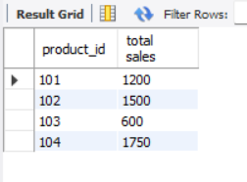

**Ques 2 Write a query to find the total number of products sold in each region.**

* **select region , sum(quantity) as "total number of product sold" from sales**
* **group by region;**

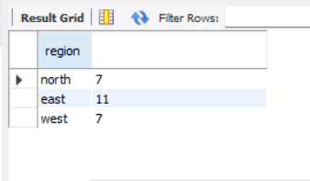

**Ques 3 Write a query to get the average sales amount per product.**

* **select product_id,avg(quantity*unit_price) as "average sales amount per product" from sales**
* **group by product_id;**

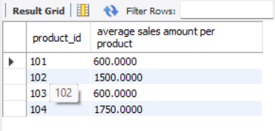

**Ques 4 Find the regions where total sales are more than 3000.**

* **select region , sum(quantity*unit_price) as"total sales" from sales**
* **group by region**
* **having sum(quantity*unit_price)>3000;**

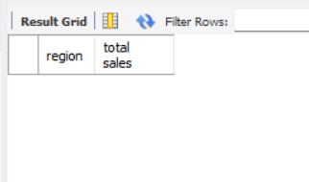

**Ques 5 Write a query to get the maximum quantity sold for each product.**

* **select product_id,max(quantity) from sales**
* **group by product_id;**

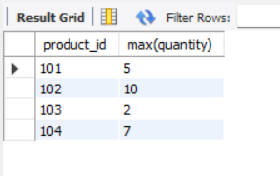

**Ques 6 Write a query to calculate the average quantity of products sold per region.**

* **select region, avg(quantity) from sales**
* **group by region;**

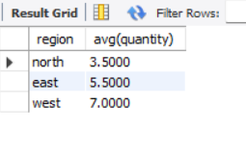

**Ques 7 Find the product IDs that have generated a total sales amount of more than 1000.**

* **select product_id ,sum(quantity*unit_price) from sales**
* **group by product_id**
* **having sum(quantity*unit_price)>1000;**

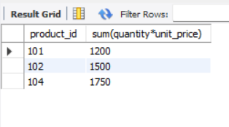

**Ques 8 Write a query to get the total number of sales (rows) made for each customer.**

* **select customer_id,count(quantity) from sales**
* **group by customer_id;**

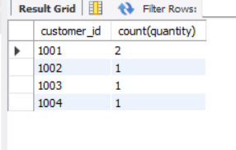

**Ques 9 Find the products for which the average quantity sold is less than 5.**

* **select product_id , avg(quantity) from sales**
* **group by product_id**
* **having avg(quantity)<5;**

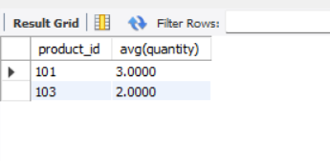

**Ques 10 Write a query to find the sum of total sales for each customer in each region.**

* **select customer_id,region,sum(quantity*unit_price) from sales**
* **group by customer_id,region;**

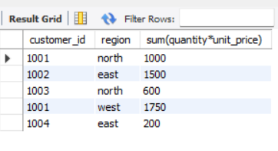

**Ques 11 Write a query to calculate the total sales for each month.**

* **select sales_date,sum(quantity*unit_price) from sales**
* **group by sales_date;**

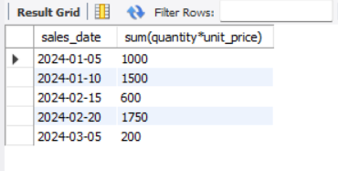

**Ques 12 Find the regions where the average unit price is more than 200.**

* **select region,avg(unit_price) from sales**
* **group by region**
* **having avg(unit_price)>200;**

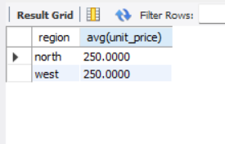

**Ques 13 Write a query to get the minimum and maximum quantity sold per region.**

* **select region , min(quantity),max(quantity) from sales**
* **group by region;**

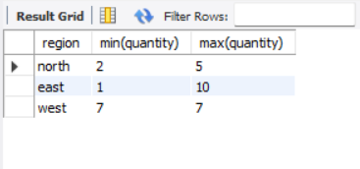

**Ques 14 Find the customers who have made more than 2 purchases.**

* **select customer_id,count(product_id) from sales /* query*/**
* **group by customer_id**
* **having count(product_id)>1;**

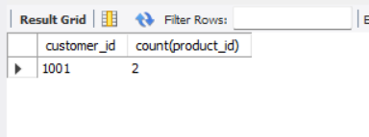

**Ques 15 Write a query to find the total sales for each product and filter only those products where the total sales exceed 1500.**

* **select product_id,sum(quantity*unit_price) from sales**
* **group by product_id**
* **having sum(quantity*unit_price)>1500;**

